加入了握手同步机制，对于握手机制的学习参考了以下几个链接

<https://blog.csdn.net/qq_39814612/article/details/105795252>

<https://blog.csdn.net/weixin_43067657/article/details/89645337>

<https://blog.csdn.net/m0_57113037/article/details/120928334>

自己先做了一个练手

module tx(tclk,reset_tclk,t_rdy,data_avail,transmit_data,t_data,r_ack);

input tclk;

input reset_tclk;

input data_avail;

input [31:0]transmit_data;

input r_ack;

output t_rdy;

output t_data;

localparam IDLE_T = 2'd0,

ASSERT_T_RDY = 2'd1,

DEASSERT_T_RDY = 2'd2;

reg [1:0] t_hndshk_state,t_hndshk_state_nxt;

reg t_rdy,t_rdy_nxt;

reg [31:0] t_data,t_data_nxt;

reg r_ack_tclk;

always@(*)begin

t_hndshk_state_nxt = t_hndshk_state;

t_rdy_nxt = 1'b0;

t_data_nxt = t_data;

case(t_hndshk_state)

IDLE_T:begin

if(data_avail) begin

t_rdy_nxt = 1'b1;

t_hndshk_state_nxt = ASSERT_T_RDY;

t_data_nxt = transmit_data;

end

end

ASSERT_T_RDY:begin

if(r_ack_tclk)begin

t_rdy_nxt = 1'b0;

t_hndshk_state_nxt = DEASSERT_T_RDY;

t_data_nxt = 'd0;

end

else begin

t_rdy_nxt = 1'b1;

t_data_nxt = transmit_data;

end

end

DEASSERT_T_RDY:begin

if(!r_ack_tclk)begin

if(data_avail)begin

t_rdy_nxt = 1'b1;

t_hndshk_state_nxt = ASSERT_T_RDY;

t_data_nxt = transmit_data;

end

else begin

t_hndshk_state_nxt = IDLE_T;

end

end

end

endcase

end

always@(posedge tclk or negedge reset_tclk)begin

if(!reset_tclk)begin

t_rdy <= 1'b0;

t_hndshk_state <= IDLE_T;

t_data <= 32'h00000000;

r_ack_tclk <= 1'b0;

end

else begin

t_rdy <= t_rdy_nxt;

t_hndshk_state <= t_hndshk_state_nxt;

t_data <= t_data_nxt;

r_ack_tclk <= r_ack;

end

end

endmodule

module rx(rclk,reset_rclk,t_rdy,t_data,r_ack);

input rclk,reset_rclk;

input t_rdy;

input[31:0] t_data;

output r_ack;

reg r_hndshk_state,r_hndshk_state_nxt;

reg t_rdy_rclk;

reg[31:0] t_data_rclk,t_data_rclk_nxt;

reg r_ack,r_ack_nxt;

localparam IDLE_R = 1'b0,

ASSERT_ACK = 1'b1;

always@(*)begin

r_hndshk_state_nxt = r_hndshk_state;

r_ack_nxt = 1'b0;

t_data_rclk_nxt = t_data_rclk;

case(r_hndshk_state)

IDLE_R:begin

if(t_rdy_rclk)begin

r_hndshk_state_nxt = ASSERT_ACK;

t_data_rclk_nxt = t_data;

r_ack_nxt = 1'b1;

end

end

ASSERT_ACK:begin

if(!t_rdy_rclk)begin

r_hndshk_state_nxt = IDLE_R;

r_ack_nxt = 1'b0;

end

else begin

r_ack_nxt = 1'b1;

end

end

endcase

end

always@(posedge rclk or negedge reset_rclk)begin

if(!reset_rclk)begin

r_hndshk_state <= IDLE_R;

t_data_rclk <= 1'b0;

t_rdy_rclk <= 1'b0;

r_ack <= 1'b0;

end

else begin

r_hndshk_state <= r_hndshk_state_nxt;

t_data_rclk <= t_data_rclk_nxt;

t_rdy_rclk <= t_rdy;

r_ack <= r_ack_nxt;

end

end

endmodule

module tb;

reg tclk_tb,rclk_tb;

reg [31:0] transmit_data_tb;

reg reset_tclk_tb,reset_rclk_tb;

reg data_avail_tb;

wire t_rdy_tb;

wire [31:0] t_data_tb;

wire r_ack_tb;

parameter CLK_HALF_PERIOD1 = 5;

parameter CLK_HALF_PERIOD2 = 8;

parameter RESET_DELAY = 100;

initial begin

tclk_tb = 0;

rclk_tb = 0;

end

always #CLK_HALF_PERIOD1 tclk_tb = ~tclk_tb;

always #CLK_HALF_PERIOD2 rclk_tb = ~rclk_tb;

initial begin

reset_rclk_tb = 0;

reset_tclk_tb = 0;

#RESET_DELAY reset_rclk_tb = 1;

reset_tclk_tb = 1;

end

initial begin

#500;

data_avail_tb = 1;

transmit_data_tb = 32'h96431346;

end

transmit transmit_test

(.tclk(tclk_tb),

.reset_tclk(reset_tclk_tb),

.t_rdy(t_rdy_tb),

.data_avail(data_avail_tb),

.transmit_data(transmit_data_tb),

.t_data(t_data_tb),

.r_ack(r_ack_tb));

receiver receiver_test

(.rclk(rclk_tb),

.reset_rclk(reset_rclk_tb),

.t_rdy(t_rdy_tb),

.t_data(t_data_tb),

.r_ack(r_ack_tb));

endmodule

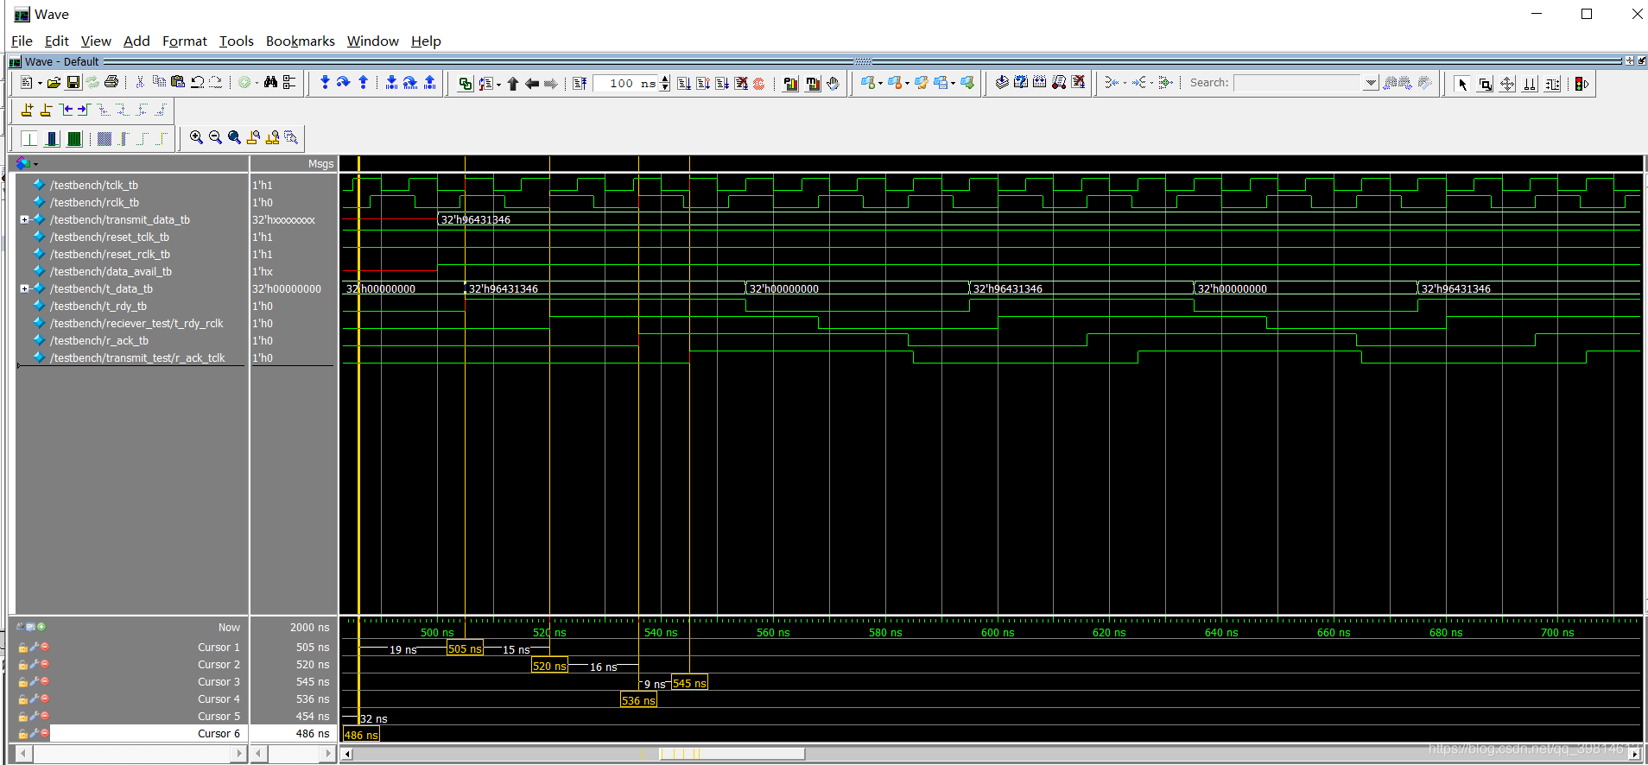

对于这次作业，并不需要特别复杂的握手机制，简单的半握手机制便可以完成

module adv_hw8_2

(

input req,

input clk_2,

input rst,

input [3:0] data,

output [3:0] avg

);

reg [2:0]cnt;//握手次数计数器

reg DFF1,DFF2;//req的同步器

//reg [3:0] data_DFF1,data_DFF2;//数据缓冲器

reg [5:0] AU;//算数单元

reg [3:0] current_state,next_state;//状态寄存器

//req经同步器同步

always@(posedge clk_2)

begin

DFF1 <= req;

DFF2 <= DFF1;

end

parameter

IDLE = 4'd0,

REQ_ACTIVE = 4'd1,

REQ_RELEASE = 4'd2;

always@(posedge clk_2 or posedge reset)

begin

if(rst)

current_state <= IDLE;

else

current_state <= next_state;

end

always@(*)

begin

next_state = IDLE;

case(current_state)

IDLE :

begin

cnt = 3'd0;

AU = 6'd0;

next_state = REQ_ACTIVE;

end

REQ_ACTIVE :

begin

if(DFF2)

begin

cnt = cnt + 1'b1;//计数握手一次

AU = AU + data;//存入数值并计算

next_state = REQ_RELEASE;//握手成功，等待释放

avg = AU[5:2];//输出当前和/4的结果

end

else

next_state = REQ_ACTIVE;//否则继续等待握手

end

REQ_RELEASE :

begin

if(!DFF2)

begin

next_state = REQ_ACTIVE;//释放成功，等待下次握手

if(cnt == 3'd4)//握手四次后清零

begin

cnt = 3'd0;

AU = 6'd0;

end

else;

end

else

next_state = REQ_RELEASE;//否则继续等待释放

end

default :

next_state = IDLE;

endcase

end

endmodule

仿真结果：

0.05x:

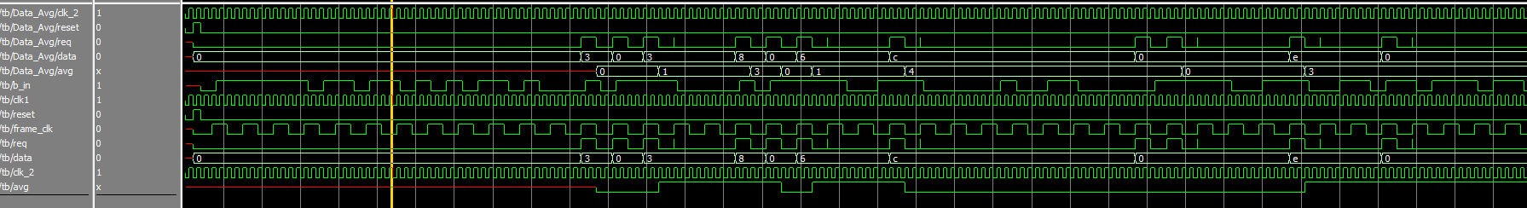

放大局部可以看到求均值的功能实现了

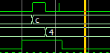 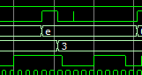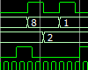

1x:

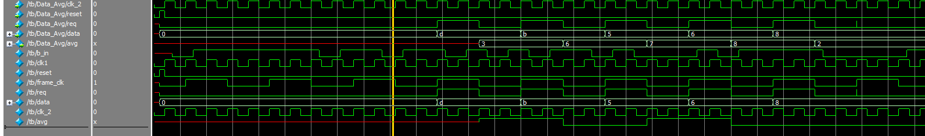

2x:

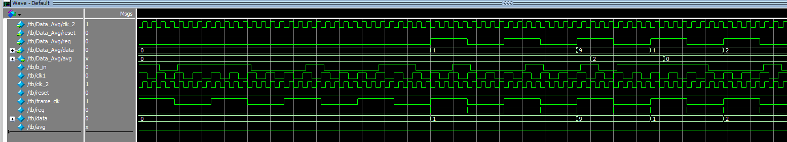

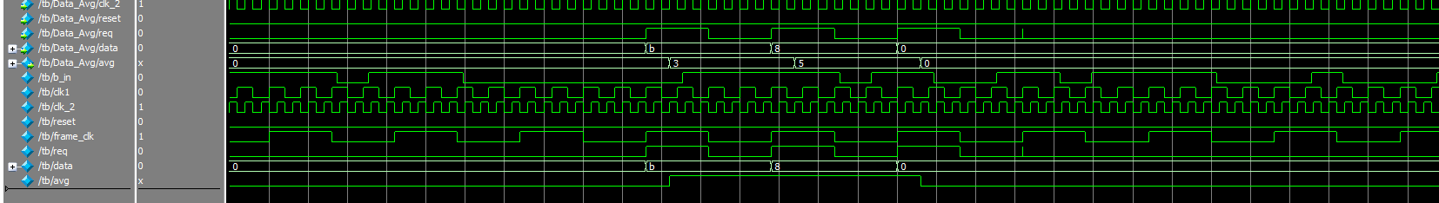

3x:

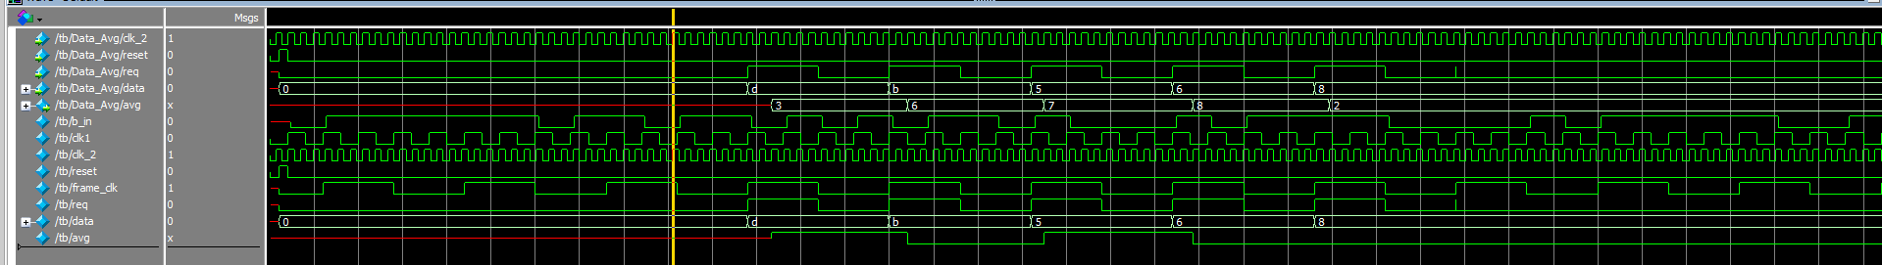

8x:

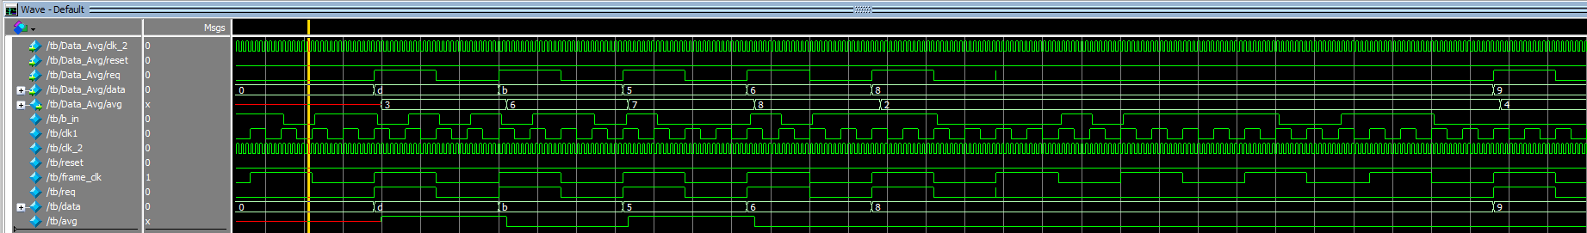

主要区别在于上一题需要注意采样信号的频率，clk_1同时控制着两个模块

本题需要在握手的时候才传输有效数值，要在释放后等待下一个数值的输入，wave会输出一些无效数值